Report
CO5_AT2 Assessment
Q22. Graph Partition Problem Using Backtracking
1. Aim
To design and implement a Backtracking algorithm to partition the vertices of a graph into two equal-sized subsets while applying pruning techniques to eliminate invalid partitions.

2. Problem Statement
The Graph Partition Problem involves dividing the vertices of a graph into two subsets of equal size. Each vertex must belong to exactly one subset, and all vertices must be assigned.
The objective is to use the Backtracking technique to explore possible assignments of vertices into two partitions. Since the number of possible assignments grows exponentially, pruning is applied to eliminate invalid paths when one partition exceeds its allowed size.

3. Objectives
- Represent a graph using an adjacency matrix.
- Divide graph vertices into two equal-sized subsets.
- Apply Backtracking to explore possible assignments.
- Maintain balance between the two partitions.
- Use pruning to eliminate invalid assignments.
- Analyze the time and space complexity of the algorithm.

4. Input and Output
Input
The input is a graph represented using an adjacency matrix.
Example:
Graph = [
[0, 1, 1, 0],
[1, 0, 1, 1],
[1, 1, 0, 1],
[0, 1, 1, 0]
]
The graph contains four vertices:
V = {0, 1, 2, 3}
Since there are four vertices, each partition must contain:
4 / 2 = 2 vertices
Output
Two subsets containing an equal number of vertices.
Example:
Set A = [0, 1]
Set B = [2, 3]

5. Algorithm
- Read the graph.
- Find the number of vertices.
- Check whether the number of vertices is even.
- Calculate the required size of each partition as n / 2.
- Start with empty Set A and Set B.
- Select a vertex and assign it to Set A.
- Recursively assign the remaining vertices.
- Backtrack and assign the vertex to Set B.
- Apply pruning when a partition exceeds the required size.
- When all vertices are assigned, check whether both sets have equal size.
- Display the valid partitions.

6. Pseudocode
ALGORITHM GraphPartition(graph)

INPUT:
graph – adjacency matrix of a graph

OUTPUT:
Two equal-sized subsets A and B

BEGIN

n ← number of vertices

IF n is odd THEN
PRINT "Equal partition is not possible"
STOP
END IF

target ← n / 2

A ← empty set
B ← empty set

CALL Backtrack(0)

END

PROCEDURE Backtrack(vertex)

IF size(A) > target OR size(B) > target THEN
RETURN
END IF

IF vertex = n THEN

IF size(A) = target AND size(B) = target THEN
Store or Print A and B
END IF

RETURN
END IF

IF size(A) < target THEN
Add vertex to A
CALL Backtrack(vertex + 1)
Remove vertex from A
END IF

IF size(B) < target THEN
Add vertex to B
CALL Backtrack(vertex + 1)
Remove vertex from B
END IF

END PROCEDURE

7. Python Source Code
# Graph Partition Problem using Backtracking
# Course: Design and Analysis of Algorithms
# Assessment: CO5_AT2

def graph_partition(graph):
n = len(graph)

# Equal partition requires an even number of vertices
if n % 2 != 0:
print("Equal partition is not possible for odd number of vertices.")
return []

target = n // 2

set_a = []
set_b = []
solutions = []

def backtrack(vertex):

# Pruning condition
if len(set_a) > target or len(set_b) > target:
return

# Base case: all vertices are assigned
if vertex == n:
if len(set_a) == target and len(set_b) == target:
solutions.append((set_a.copy(), set_b.copy()))
return

# Assign vertex to Set A
if len(set_a) < target:
set_a.append(vertex)
backtrack(vertex + 1)
set_a.pop()

# Assign vertex to Set B
if len(set_b) < target:
set_b.append(vertex)
backtrack(vertex + 1)
set_b.pop()

backtrack(0)

return solutions

# Graph represented using adjacency matrix
graph = [
[0, 1, 1, 0],
[1, 0, 1, 1],
[1, 1, 0, 1],
[0, 1, 1, 0]
]

solutions = graph_partition(graph)

print("GRAPH PARTITION USING BACKTRACKING")
print("-" * 40)

if solutions:
set_a, set_b = solutions[0]

print("Set A:", set_a)
print("Set B:", set_b)
print("Both sets contain equal number of vertices.")
print("Total valid partitions found:", len(solutions))

else:
print("No valid partition found.")

8. Output
GRAPH PARTITION USING BACKTRACKING
----------------------------------------
Set A: [0, 1]
Set B: [2, 3]
Both sets contain equal number of vertices.
Total valid partitions found: 6
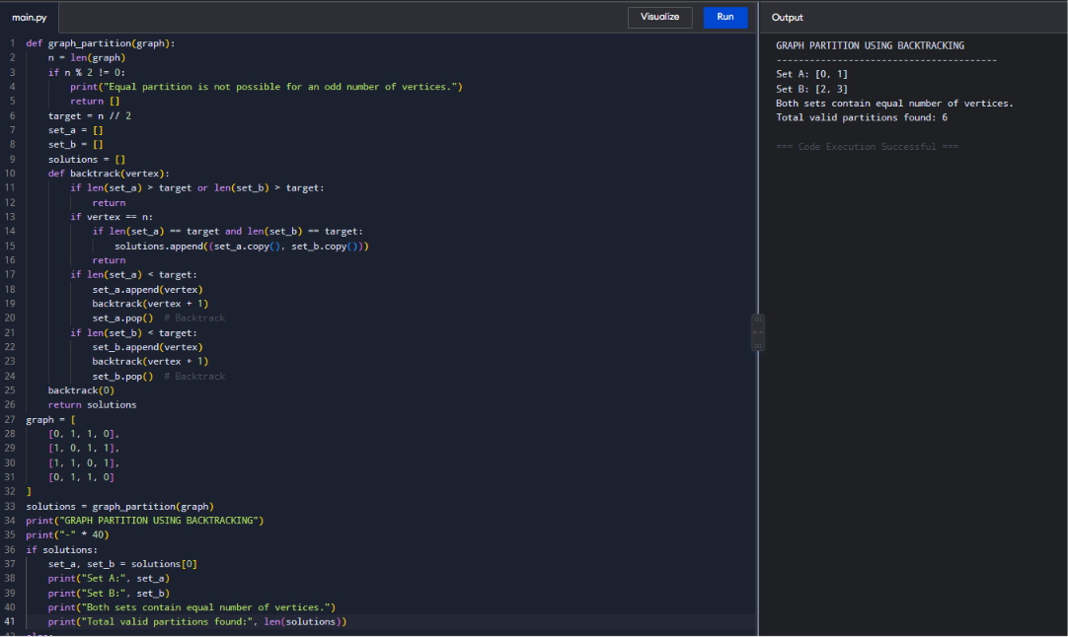
9. Working of the Algorithm
Consider the vertices:
V = {0, 1, 2, 3}
The number of vertices is 4.
Therefore:
Size of Set A = 2
Size of Set B = 2
The algorithm begins assigning vertices to the two sets.
One possible assignment is:
Vertex 0 → Set A
Vertex 1 → Set A
Vertex 2 → Set B
Vertex 3 → Set B
Therefore:
Set A = {0, 1}
Set B = {2, 3}
Both sets contain two vertices, so this is a valid balanced partition.

10. Backtracking Approach
Backtracking systematically explores all possible assignments.
For every vertex, there are two choices:
- Assign it to Set A.
- Assign it to Set B.
After making a choice, the algorithm recursively processes the next vertex.
If an assignment becomes invalid, the algorithm returns to the previous state and tries another option. This process is called backtracking.

11. Pruning Technique
Pruning prevents unnecessary exploration of invalid solutions.
The algorithm stops a branch if:
Size of Set A > n/2
OR
Size of Set B > n/2
For example, if the graph has four vertices and Set A already contains three vertices:
Set A = {0, 1, 2}
This branch cannot produce an equal partition because Set A has exceeded its allowed size.
Therefore, the algorithm immediately stops exploring that branch.
This improves practical efficiency by reducing unnecessary recursive calls.

12. Completeness of the Algorithm
The algorithm is complete because it explores all possible valid assignments of vertices.
For each vertex, both possibilities are considered:
- Assignment to Set A.
- Assignment to Set B.
Pruning only eliminates branches that cannot satisfy the equal-size condition. Therefore, no valid balanced partition is incorrectly removed.

13. Time Complexity
For each vertex, there are two possible choices.
Therefore, the total number of possible assignments in the worst case is:
2ⁿ
Hence:
Time Complexity = O(2ⁿ)
The pruning technique improves practical performance but does not change the worst-case exponential complexity.

14. Space Complexity
The algorithm uses recursion and stores the vertices in two sets.
The maximum recursion depth is equal to the number of vertices.
Therefore:
Space Complexity = O(n)

15. Analysis
The Backtracking algorithm is suitable for solving the Graph Partition Problem because it systematically explores possible vertex assignments.
The main advantages are:
- It guarantees exploration of all possible valid solutions.
- Pruning reduces unnecessary computations.
- It ensures equal-sized partitions.
- It is easy to understand and implement.
However, the algorithm has exponential time complexity. Therefore, it may become inefficient for graphs containing a large number of vertices.
For large-scale graph partitioning problems, more advanced heuristic or approximation algorithms may be preferred.

16. Result
The Graph Partition Problem was successfully implemented using the Backtracking technique.
The graph vertices were divided into two equal-sized subsets:
Set A = [0, 1]
Set B = [2, 3]
The algorithm used pruning to eliminate invalid partitions and successfully demonstrated the Backtracking approach.

17. Conclusion
The Graph Partition Problem was solved using Backtracking by assigning each vertex to one of two subsets. The algorithm maintained equal partition sizes and used pruning to avoid exploring invalid assignments.
The approach is complete and can identify all valid balanced partitions. Although the worst-case time complexity is O(2ⁿ), pruning improves practical performance by reducing unnecessary recursive calls.
This experiment demonstrates the importance of Backtracking in solving combinatorial problems where multiple possible solutions must be systematically explored.

